NATIONAL INSTITUTE OF TECHNOLOGY, KURUKSHETRA
THEORY EXAMINATION
Question Paper
Month and Year of the Examination: May/June-2011
Programme: B.Tech Semester: - 4th Semester
Subject: - Microprocessor-I
Course No: -COT-208 Maximum Marks: - 50
Number of Questions to be attempted: -5 Time allowed: - 3 Hours
Total No. of Questions: -7 Total No. of Pages used: -4
Unless stated otherwise, the symbols have their usual meanings in context with subject. Assume suitably and state, additional data required, if any. The Candidates, before starting to write the solutions, should please check the question Paper for any discrepancy, and also ensure that you have been delivered the question paper of right course no. and right subject title.

Note: - This paper contains three sections A, B, C. Section A is compulsory having one question of ten marks. And also attempt any four questions from section B & C choosing at least two questions from each section.

Section A
 | (a)Q:-Justify the statement that 8086 has pipelined architecture.  (b)Q:-How many channels are available in one DMA controller chip (8237). Write the name of channels also.  (c)Q:-How many addressing lines are required for interfacing two chips of number 74LS4016.  (d)Q:-Difference between arithmetic shift and logical shift.  (e)Q:-How many clock cycles are required to generate a delay of 5ms.  (f)Q:-What is significance of multiplexed 7-segment display.  (g)Q:-What is port A address in the configuration shown below:-  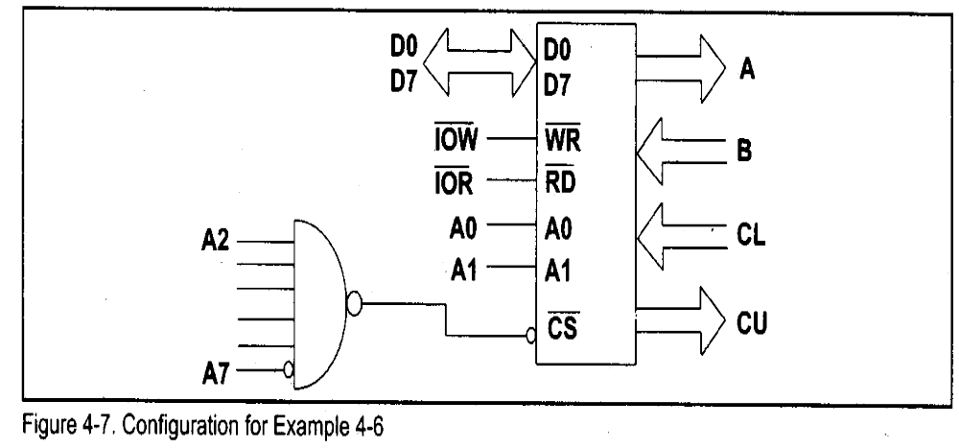  (h)Q:-Tell the name of configuration shown below with reason:-  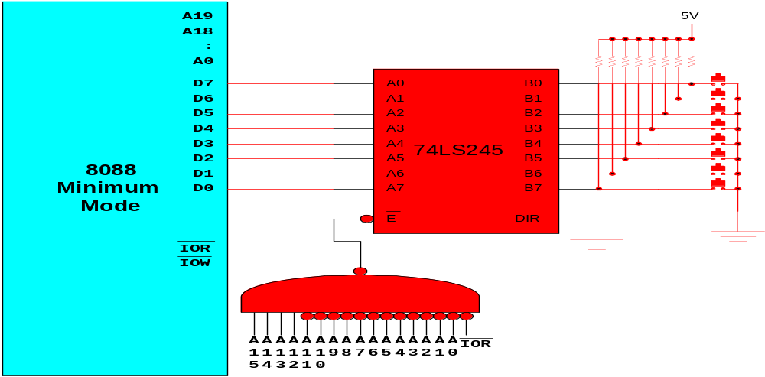  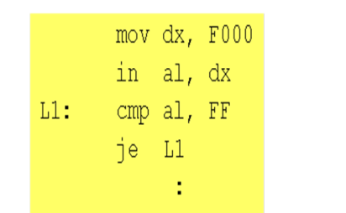  (i)Q:-Difference between procedure and macro.  (j)Q:-Write all control signals used in Memory Interfacing.  Section-B | 10 X 1= 10
 | (a)Q:-Write a program to convert 16-bit binary number into equivalent Gray code.  (b)Q:-Explain the clear differences between synchronous and asynchronous communication with diagram. | 5  5
 | (a)Q:- What do you mean I/O port. Write the various steps for interfacing I/O device with 8086.  (b)Q:-Design a memory system that has total 32K x 8 ROM and 32K x 8 RAM .The ROM and RAM chips are available in modules of 8K x 8. The memory map should be specified below:-  - ROM 1-F0000H-F1FFFH  - ROM2-Decide suitably for practical system (with reason)  - RAM 1- Contains interrupt Vector Table  - RAM 2- 30000H-31FFFH  - RAM 3- 40000H-41FFFH  - RAM 4- 50000H-51FFFH | 5  5
 | (a)Q:- Describe various techniques with example to access operands in 8086.  (b)Q:- The diagram shown below is the connection between 8255 and a printer. Write ALP to print the following message:  “Department of Computer Engineering, National Institute of Technology, Kurukshetra$”.  The $ sign indicates the end of the message.(Assume the port address, if required). | 5  5
Section C

 | (a)Q:-A configuration is shown below:- Write ALP to make running effect(initially moving from down to up). Every time the lowest button is pressed, it changes the direction of movement. When the highest button is pressed, the program terminates.  1  The Circuit  A  1  5  8086  Minimum  Mode  A18  A0  :  D7  D6  IOR  IOW  A19  D5  D4  D3  D2  D1  D0  A  1  4  A  1  3  A  1  2  A  1  1  A  1  0  A  9  A  8  A  7  A  6  A  5  A  4  A  3  A  2  A  1  A  0  IOR  5V  74LS245  B0  B1  B2  B3  B4  B5  B6  B7  A0  A1  A2  A3  A4  A5  A6  A7  E  DIR  A  1  5  A  1  4  A  1  3  A  1  2  A  1  1  A  1  0  A  9  A  8  A  7  A  6  A  5  A  4  A  3  A  2  A  1  A  0  IOW  74LS373  Q0  Q1  Q2  Q3  Q4  Q5  Q6  Q7  D0  D1  D2  D3  D4  D5  D6  D7  OE  LE  (b)Q:-Explain the following instructions/concepts with example:-  - XCHG  - LAHF  - SAHF  - XLAT  - Segment Override Prefix | 5  1+.5+.5+1+2
 | (a)Q:-(a): Find the port addresses for figure shown below.  (b):Find the control word if PA=in, PB=out, PC_{0 –} PC₃ = out and PC4₋ PC₇ = out.  (c): Program the 8255 to get data from port A and send it to port B and Port C.  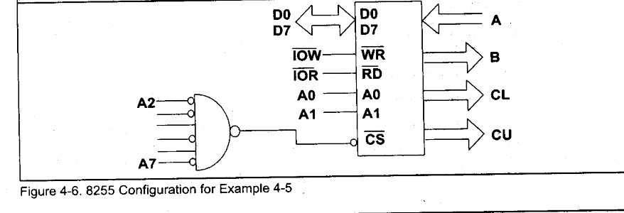  (b)Q:- A Circuit diagram is shown below. Write about the working of the  circuit in your words.  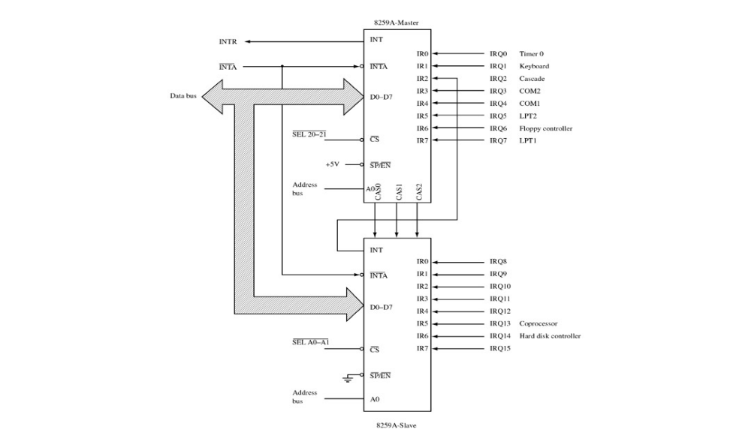 | 1+1+3  5
 | (a)Q:-Explain Memory Segmentation of 8086 with an Analogy( except  house-colony example ).  (b)Q:-Interface ADC080 at port 0260H for data and 0270H to test the INTR  pin. Draw the necessary diagram.  OR  Q:- Convert the following instructions into its machine code and also  specify how many bytes are there in each instruction.  - MOV BP[SI + 500H], 7293H  - SHR AX  - ADD AX, 5000H | 5  5

